ARMY PUBLIC SCHOOL
QUESTION BANK OF CLASS VIII

SUBJECT : SCIENCE
CHAPTER: 12 FRICTION
Q1. MCQ
- Whenever the surfaces in contact tend to move or move with respect to each other, the force of friction comes into play
(a) only if the objects are solid.
(b) only if one of the two objects is liquid.
(c) only if one of the two objects is gaseous.
(d) irrespective of whether the objects are solid, liquid or gaseous.
- On what force of friction depends?
a. Smoothness of surface
b. Roughness of surface
c. Inclination of surface
d. Inclination of surface
3. Four children were asked to arrange forces due to rolling, static and sliding frictions in an increasing order. Their arrangements are given below. Choose the correct arrangement.
(a) Rolling, Static, Sliding
(b) Static, Rolling, Sliding
(c) Rolling, sliding, static
(d) Sliding, Static, Rolling
Q2. ASSERTION AND REASON :
- Assertion : Friction always opposes the motion.
Reason : Whenever one surface moves or tries to move over another surface, the force of friction starts acting on the surfaces.

Assertion (A) When a bicycle is in motion, the force of friction exerted by the ground on the two wheels is always in forward direction.
Reason (R) The frictional force acts only when the bodies are in contact.

Q3. PICTURE BASED
- 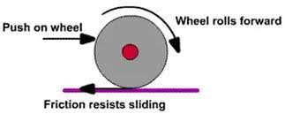

In the above diagram , friction shown is :
- Sliding friction
- Static friction
- Rolling friction
- None
- 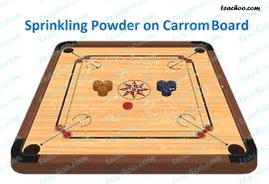
In the above diagram Telcom powder is sprinkled for
- Reducing friction
- Increasing friction
- For shining
- None

- 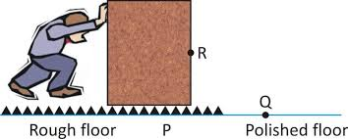

See the diagram and which one is correct statement for this?
- Friction is less for Polished surface
- Friction is more for Polished surface
- Friction is less for Rough surface
- Friction is zero for Polished surface

Q4. Paragraph based questions:

A bicycle and a motor mechanic uses grease between the moving parts of these machines. Powder is sprinkled on the carrom board to reduce friction friction in order to increase efficiency. When oil, grease or graphite is applied between the moving part of a machine, a thin layer is formed there and moving surfaces do not directly rub against each other. Interlocking of irregularities is avoided to a great extent. Movement becomes smooth. The substances which reduce friction are called lubricants. In some machines, it may not be advisable to use oil as lubricant. An air cushion between the moving parts is used to reduce friction.

- The role of lubricants is ?
i) reduce friction ii) increase friction iii) not to increase or decrease friction
- Friction is caused due to
i)irregularities in surface ii)Interlocking of regularities
iii) both of these iv) none of these

Q5. Short answer type questions :
- We use ball bearings between the hub and axle of ceiling fan and bicycles. Why?
- Write advantages and disadvantages of friction.
- What is sliding friction?
- In which direction frictional force acts on a moving object.
- What is easier- rolling or sliding?
- What is drag?
- Hoes does the friction get affected by the nature of surface

CHAPTER: 13 SOUND

Q1. MCQ
- The hearing range of human ear is
(a) 20 Hz to 20,000 Hz
(b) less than 20 Hz
(c) more than 20,000 Hz
(d) 20 Hz to 25,000 Hz
- Pitch of sound is determined by its
(a) frequency
(b) speed
(c) amplitude
(d) loudness
- 1 hertz is equal to
(a) 1 vibration per minute
(b) 10 vibrations per minute
(c) 60 vibrations per minute
(d) 600 vibrations per minute

Q2. ASSERTION AND REASON :

a)Both Assertion and reason are correct and reason is correct explanation for Assertion
b)Both reason and assertion are correct but Reason is not the correct explanation for assertion
c)Assertion is correct but the Reason is incorrect.
d)Assertion is incorrect but Reason is correct.

- A : Sound can not be propagated at moon.
R: sound requires a medium to propagate.

- A: : The sound produced by the flute is more shrill than the sound produced by a table.
R: Frequency produced by the flute will be greater than the frequency produced by the table.
- A :Every vibrating body is a source of sound.
R :All sounds are audible.

Q3. PICTURE BASED

1. The sound wave with high frequency can be given by

A)

B)

C)

D)
2.
A student performed an experiment as shown in the figure.
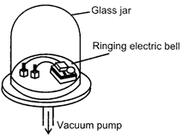
What would be happened as air was pumped out of the jar and the electric bell rang?

A) The sound became louder.

B) The sound became fainter first and then louder once all the air was pumped out.

C) The sound could not be heard anymore.

D) The sound was the same as before.

3. in which of following wave Loudness will be more.
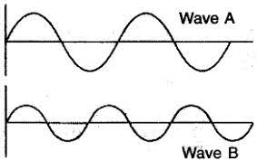

Q4. PARAGRAPH BASED:
We know that we need a vibrating body for the production of sound. Can we hear the sound of all vibrating bodies? The fact is that sounds of frequencies less than about 20 vibrations per second (20 Hz) cannot be detected by the human ear. Such sounds are called inaudible. On the higher side, sounds of frequencies higher than about 20,000 vibrations per second (20 kHz) are also not audible to the human ear. Thus, for human ear, the range of audible frequencies is roughly from 20 to 20,000 Hz.
QA. What is the frequency of ultrasound?
- Below 20 Hz b) above 20 KHz c) above 200 Hz
QB. What is unit of frequency:
- Hertz b) Decibel c) metre
QC. Calculate time-period if frequency is 20 vibrations per second.
- 0.05 sec b)0.02 sec c) 0.03 sec

Q5. SHORT QUESTION ANSWER :
- A simple pendulum makes 20 oscillations in 40 seconds. What is the time period and frequency of its oscillation?
- Sonali heard sound of thunderbolt 5 second after she saw flash of lightning. How far is she from the place where lightning occurs? (speed of sound = 330 m/s)
- What do you mean by oscillatory motion?
- What are the methods to control noise pollution?
- A string musical instrument was first plucked with a force of smaller magnitude and then with a force of greater magnitude. In which case would the instrument produce a louder sound?
- Draw well labelled diagram of human ear and write its structure.

--------------------------------------------------------------------

CHAPTER: 14 CHEMICAL EFFECTS OF ELECTRIC CURRENT
Q1. MCQ:
Q1. ASSERTION : Corrosion is a gradual destruction of metal in environment
REASON : Corrosion of iron cannot be prevented by electroplating
Q2. ASSERTION: If a little salt is dissolved to the distilled water, it becomes good conductor of electricity
REASON : Rainwater is a conductor of electricity
Q3. ASSERTION: The liquid that conduct electricity is solution of acids, bases/ salts and water Statement
REASON : When electric current passes through an electrolyte, chemical changes takes place
.Q4. Picture based questions:
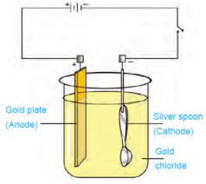

- In the above diagram Gold chloride is acting as :
- Cation b) Anion c) Electrolyte
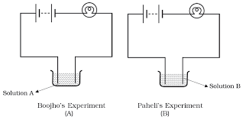
- In the above two diagrams bulb is glowing more brightly in ‘A’ , which can be interfered by this:
- A is more good conducting than B
- B is more conducting than A
- Both are equally conducting liquids
- Both are poor conductors

Read the abstract and answer the following :
Electroplating is the process of aligning another metal onto a metal. This is accomplished using an electroplating apparatus that includes a brine solution, a battery, wires, and alligator clips that hold carbon rods attached to the metal to be electroplated and the metal to be layered. The water molecule is released as the final product in this process. As a consequence, electroplating is based on the theory of electrorolysis.
Q4. An electric current is passed through a conducting solution .Following are the some observations:
- Deposits of the metal may be seen on electrodes
- Solution may get heated
- Bubbles of gas may be formed

- Only (ii) is true
- Only (i) and (ii) only
- Only (i) and (iii) are true
- All (i) ,(ii) and (iii) are true
Q5. Which of the following instrument is incorrect-
- Anode is an electrode connected to the battery
- Pure water is poor conductor of electricity
- Electrolysis is used to refining of impure metals
- Ions can have only a positive charge
Q6. The metal object on which electroplating is to is-
- Connected to the negative terminal of battery
- Connected to the positive terminal of battery
- Not connected to the battery
- None of the above
Q7.
- Why do some liquids conduct electricity? Give reason.

- Do distilled water conduct electricity ? What will happen If we add sugar to it and salt to it?
Q8. Soham made an electric circuit .He observed that the bulb did not glow but on bringing a compass needle near it shows deflection .Then he added one more cell in the circuit the bulb then started glowing.
- Why the bulb did not glow in first case but glow in the second case ?
- What does the deflection of a compass needle shows?
- Define a circuit.
- Show with the help of a diagram that lemon juice and vinegar are good conductors of electricity.
-------------------------------------------------------------------------------------------------------

CHAPTER : 15 SOME NATURAL PHENOMENA
Q1. MCQ

1)The power of an earthquake is expressed on a scale called
(a) seismic scale
(b) iron scale
(c) Richter scale
(d) large scale
2) Which instrument is used to measure earthquake?
(a) Richter scale
(b) Seismograph
(c) Polygraph
(d) None of these
3) How many types of charges are gained by rubbing objects?
(a) 2
(b) 1
(c) 3
(d) 4

Q2. ASSERTION AND REASON :
• Both Assertion and R false -A
• Assertion is false, but Reason is true.-B
• Both Assertion and R are true, and Reason is the correct explanation of A.-C
• Assertion is true, but Reason is false-D

Assertion : An earthquake will not cause uniform damage to all building in an affected area, even if they are built with the same strength and materials.
Reason : The one with its natural frequency close to the frequency of seismic wave is likely to be damaged less.

- Assertion: When a glass rod is rubbed with a silk cloth, the glass rod acquires a negative charge, and silk becomes positive.

Reason: The silk loses electrons; it has a deficiency of electrons and hence acquires positive charge. But, the glass rod has an excess of electrons. So, it becomes negatively charged.

Q3. PICTURE BASED
- The device which is shown here can be used to protect building from lightening is
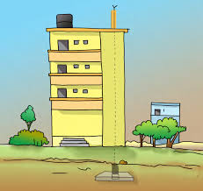
- Seismograph
- Lightening Conductor
- Cyclone detector
- Electroscope

- The device which is shown here can be used to measure earthquake is

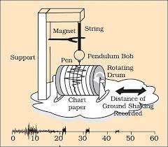

- Seismograph
- Lightening Conductor
- Cyclone detector
- Electroscope

- The device which is shown here can be used to measure charge is?
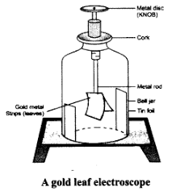

- Seismograph
- Lightening Conductor
- Cyclone detector
- Electroscope
Q4. SHORT QUESTION ANSWERS :
- Explain why a charged body loses its charge if we touch it with our hand?
- Name the scale on which the destructive energy of an earthquake is measured. An earthquake measures 3 on this scale. Would it be recorded by a seismograph? Is it likely to cause much damage?
- Suggest three measures to protect ourselves from lightning.
- Explain why a charged balloon is repelled by another charged balloon whereas an uncharged balloon is attracted by another charged balloon?
- Describe with the help of a diagram an instrument which can be used to detect a charged body?

------------------------------------------------------------------------------------------------------

CHAPTER : 16 LIGHT
Q1. MCQ
- Beam of light striking the reflecting surface is called
(a) reflecting ray
(b) incident ray
(c) refracted ray
(d) normal ray
- Band of seven colours is called
(a) VIBGYOR
(b) spectrum
(c) dispersion
(d) reflection
- In case of reflection of light, the angle of incidence (i) and the angle of reflection (r) are related as
(a) i = r
(b) i < r
(c) i > r
(d) no definite relation

Q2. ASSERTION AND REASON :
- Assertion: Light travels in a straight line.
Reason: Transparent objects allow all the light to pass through them.

- Assertion: A rainbow is formed when white light is incident on raindrops.
Reason : White light contains seven colours and it undergoes dispersion inside a raindrop

Q3. PICTURE BASED

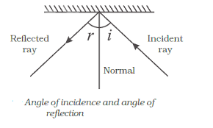
- In the above given diagram the if total angle between incident ray and reflected ray is 70 degree. What will be angle of incidence?
- 30 º 2) 45 º 3) 60 º 4) 70 º

- In the given diagram the process shown is

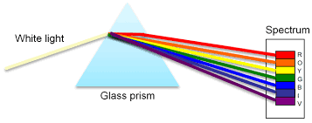

- Deflection
- Refraction
- Reflection
- Deflection

- In the given diagram which part of eye gives distinct color to the eye?

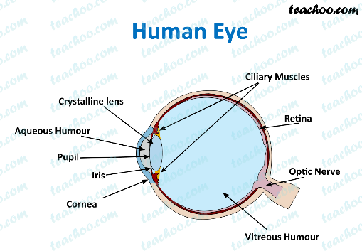

- Iris b) Pupil c) Retina d) Lens

Q4. Paragraph based question:
The lens focuses light on the back of the eye, on a layer called retina (Fig. 16.14). The retina contains several nerve cells. Sensations felt by the nerve cells are then transmitted to the brain through the optic nerve. There are two kinds of cells– (i) cones, which are sensitive to bright light and (ii) rods, which are sensitive to dim light. Cones sense colour. At the junction of the optic nerve and the retina, there are no sensory cells, so no vision is possible at that spot. This is called the blind spot.
- Night birds will have:
- More cones b) more rods iii) equal rods and cones
- The image is formed in eyes on:
- Lens b) Blind spot c)Retina d) rods

Q4 . Short answer questions :
- Write a note on ‘The Human Eye’.
- State the laws of reflection.
- Describe an activity to show that the incident ray, the reflected ray and the normal at the point of incidence lie in the same plane.
- Express the mathematical formula to calculate the number of images formed when two mirrors are inclined at θ angle.
- List the characteristics of an image formed in a plane mirror.

-----------------------------------------------------------------------------------------------------

CHAPTER : 17 . Star and Solar system
Q 1. MCQ
1. . _______________ is a constellation which looks like a distorted letter W or M.
a. Orion
b. Great Bear
c. Cassiopeia
d. Leo major
2. Which one of the following is a natural satellite of the earth?
. Venus
b. Mercury
c. Sun
d. Moon
3. The gap between the orbit of mars and Jupiter is ______________.
a. meteorite
b. meteor
c. asteroid
d. comet

Q2. Assertion and Reason :

1 ) Assertion: The stars twinkle while the planets do not.
Reason: The stars are much bigger in size than the planets.

- Assertion: Venus is the brightest planet in the solar system.
Reason: as it's blanketed by highly reflective clouds.

Q3. Picture based :
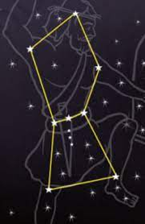
1)Identify the constellation shown in the diagram
a. Orion
b. Great Bear
c. Cassiopeia
d. Leo major

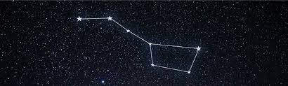
2) the constellation given in diagram is
a. Orion
b. Great Bear
c. Cassiopeia
d. Ursa major

Q4. Paragraph based questions:
The planet mercury is nearest to the Sun. It is the smallest planet of our solar system. Because Mercury is very close to the Sun, it is very difficult to observe it, as most of the time it is hidden in the glare of the Sun. However, it can be observed just before sunrise or just after sunset, near the horizon. So it is visible only at places where trees or buildings do not obstruct the view of the horizon. Mercury has no satellite of its own.
- Mercury has how many moons?
- 0
- 2
- 5
- How far away is Mercury from the sun?
- 200 million miles
- 500 million miles
- 36 million miles

Q 5. Short answer questions:
- Explain how you can locate the Pole star with the help of Ursa Major.
- Why is the distance between stars expressed in light years? What do you understand by the statement that a star is eight light years away from the Earth?
- What are meteorites?
- What are celestial objects?
- Differentiate between the following:
(a) Star and planet
(b) Asteroid and comet
(c) Meteoroid and comet
(d) Galaxy and constellation
- Explain why do we see phases of moon.

-------------------------------------------------------------------------------------------------------

Ch 18 Pollution of Air and Water :
Q 1. MCQ
- The Taj Mahal is being affected by
a. Noise pollution
b. Air pollution
c. Water pollution
d. None of these

- Green House gas is
a. Nitrogen
b. Oxygen
c. Methane
d. Carbon dioxide

- Water containing high salt concentration can be purified by
(a) boiling
(b) UV radiation
(c) filtration
(d) reverse osmosis

Q2. Assertion and Reason :

- Assertion : Pollution is always caused by human activities.
Reason : Pollution is not different from contamination.
- Assertion: Through the use of catalytic converters, unburnt hydrocarbons are changed into carbon monoxide which in turn is changed into nitrogen oxides and water.
Reason: Motor vehicles equipped with catalytic converters should use leaded petrol to protect the catalyst from degradation.
- Assertion: Photochemical smog is mainly composed of nitrogen oxides, volatile organic compounds, ozone and peroxyacetyl nitrates.
Reason: Photochemical smog develops in cold weather conditions by the interaction of secondary pollutants.

Q 4. Picture based question:
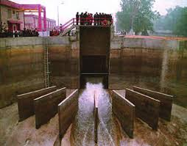

- Diagram showing above is of
  - Farm ii) Water treatment plant iii) Factory iv) Dam
- The chemical used in this process which is shown is
- Iodine b) Alcohol c) Chlorine d) Phenol

Q5 Paragraph based questions:
Read the abstract and answer the following:
The industries located in and around Agra like rubber processing, automobile, chemicals and especially the Mathura oil refinery, have been responsible for producing pollutants like sulphur dioxide and nitrogen dioxide. These gases react with the water vapour present in the atmosphere to form sulphuric acid and nitric acid. The acids drop down with rain, making the rain acidic. This is called acid rain. Acid rain corrodes the marble of the monument. The phenomenon is also called “Marble cancer”. Suspended particulate matter, such as the soot particles emitted by Mathura oil refinery, has contributed towards the yellowing of the marble.
- Which of the following gas is responsible for acid rain
i)CO₂ ii) CO iii) CH₄ iv) NO₂
B) Marble cancer means:
i) break of marble ii) yellowing of marble iii) black marblr iv) none

Q6. Short answer questions:
1)What are the factors that are responsible for water pollution?
2) What are the harmful effects of global warming?
3) What do you mean by acid rain? How does it affect both living and non-living things?
4) Name various techniques used for purification of water.
5) Why is it advised that industries should switch over to cleaner fuels such as CNG and LPG in the Taj Mahal Zone in Agra?
6) How can you prevent water pollution?

-------------------------------------------------------------------------------------------------------

